DATA STRUCTURES LABORATORY [DS Lab]

Roll No. :- [20124107]

**BASIC C PROGRAMS**

Q.1. C Program to Find ASCII Value of a Character

#include <stdio.h>

int main() {

char c;

printf("Enter a character for its ascii value ");

scanf("%c", &c);

printf("ASCII value of %c = %d", c, c);

return 0;

}

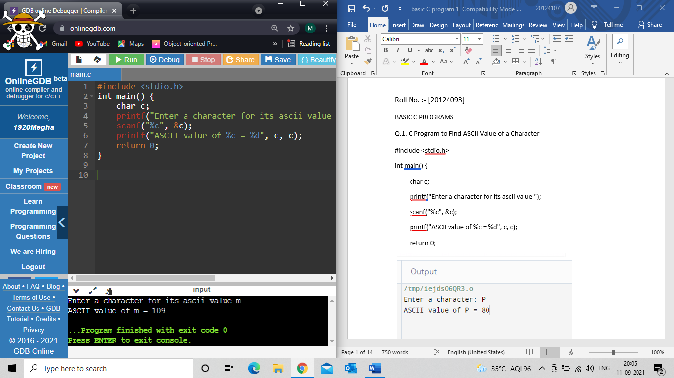

Q.2. C Program to Compute Quotient and Remainder

#include <stdio.h>

int main() {

int dividend, divisor, quotient, remainder;

printf("Enter dividend and divisor ");

scanf("%d", &dividend);

scanf("%d", &divisor);

quotient = dividend / divisor;

remainder = dividend % divisor;

printf("Quotient = %d\n", quotient);

printf("Remainder = %d", remainder);

return 0;

}

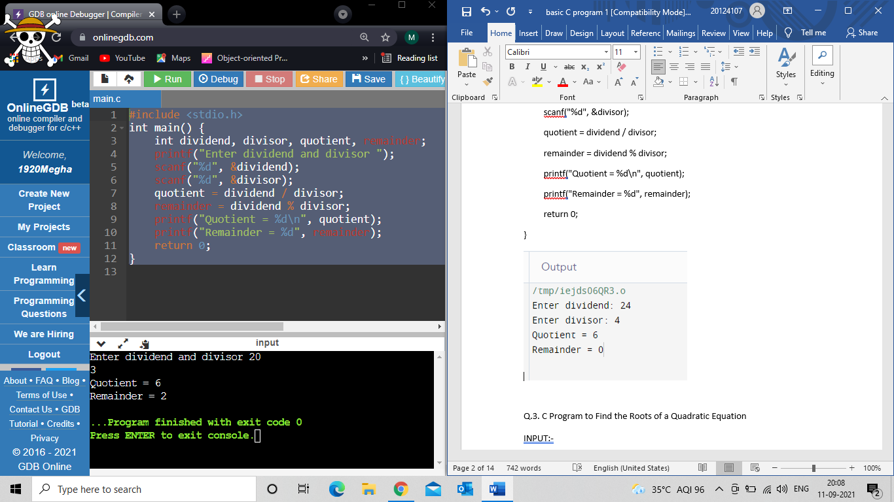

Q.3. C Program to Find the Roots of a Quadratic Equation

INPUT:-

#include <stdio.h>

#include <math.h>

int main()

{

int a, b, c, d;

double r1,r2;

printf("Enter a Quadratic function:\n");

scanf("%d%d%d", &a, &b, &c);

d = b*b - 4*a*c;

if (d<0)

{

printf("Root 1 = %.21f + i%.21f\n", -b/(double)(2*a), sqrt(-d)/(2*a));

printf("Root 2 = %.21f - i%.21f\n", -b/(double)(2*a), sqrt(-d)/(2*a));

}

else{

r1 = (-b + sqrt(d))/(2*a);

r2 = (-b - sqrt(d))/(2*a);

printf("Root 1 = %.21fn", r1);

printf("Root 2 = %.21fn", r2);

}

return 0;

}

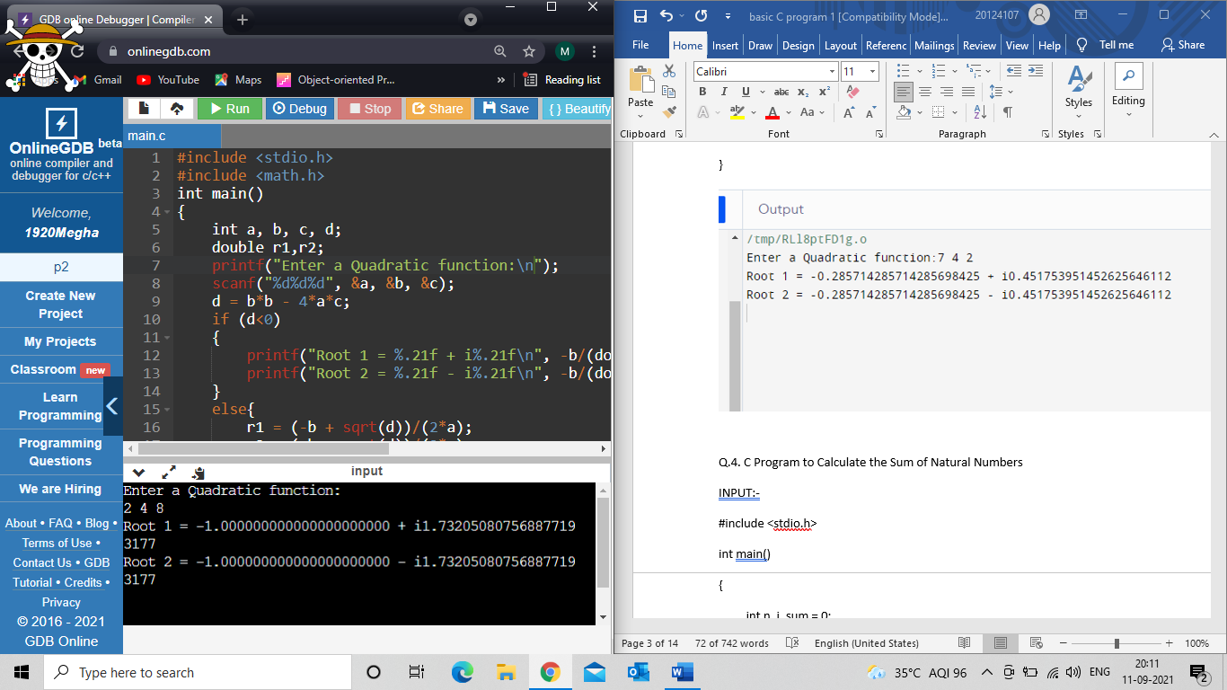

Q.4. C Program to Calculate the Sum of Natural Numbers

#include <stdio.h>

int main()

{

int n, i, sum = 0;

printf("Enter a number to find sum: ");

scanf("%d", &n);

for (i = 1; i <= n; ++i)

{

sum += i;

}

printf("Sum is of %d natural numbr is %d",n,sum);

return 0;

}

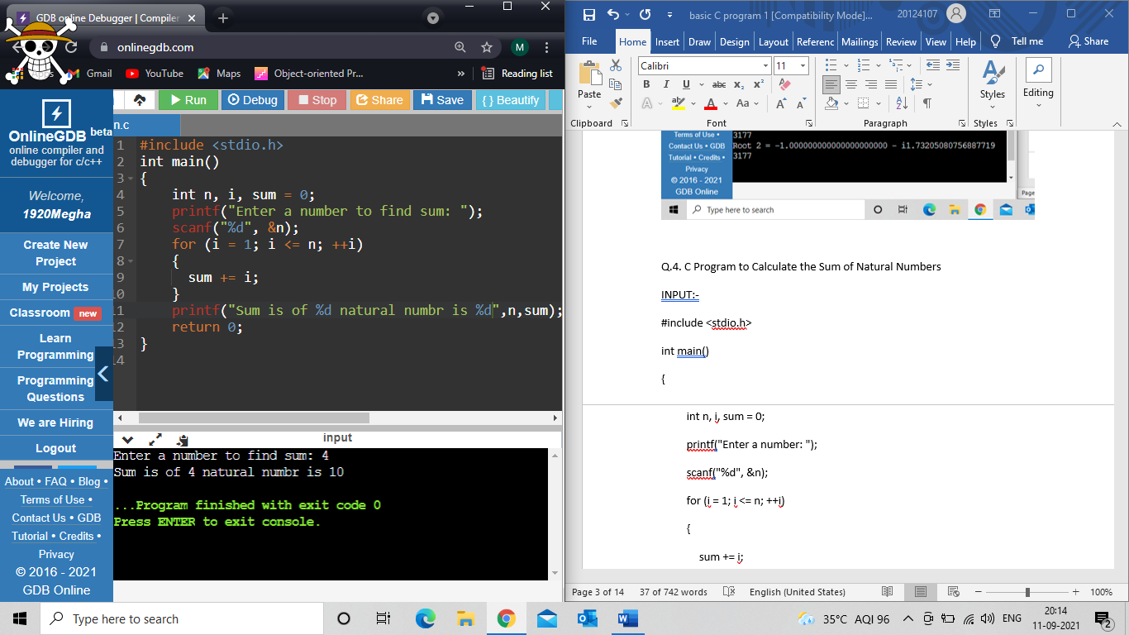

Q.5. C Program to Find Factorial of a Number

#include <stdio.h>

int main()

{

int i,n,fact=1;

printf("Enter a number to find its factorial:\t ");

scanf("%d",&n);

for (i=1;i<=n;++i)

{

fact=fact*i;

}

printf("Factorial of %d is %d" ,n ,fact);

return 0;

}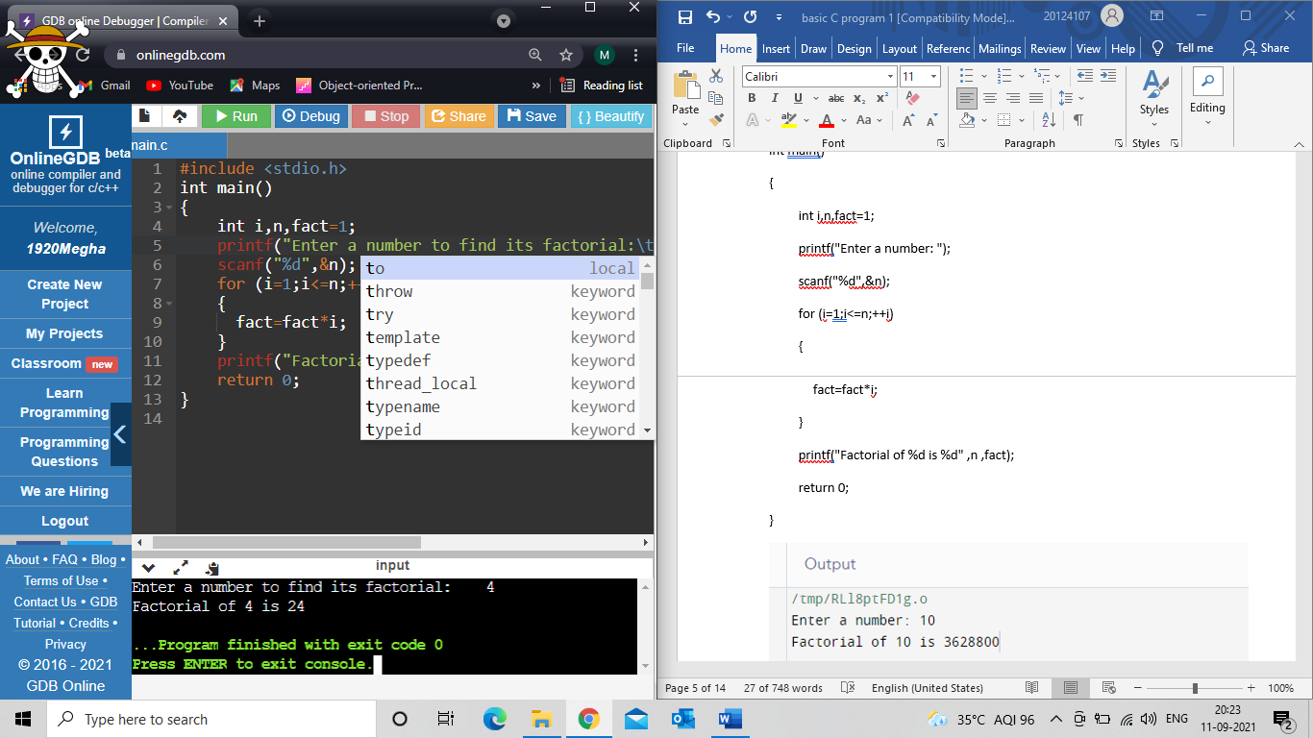

Q.6. C Program to Generate Multiplication Table

INPUT:-

#include <stdio.h>

int main()

{

int n, i;

printf("Enter a number to disply its table: ");

scanf("%d",&n);

for(i=1; i<=10; ++i)

{

printf("%d X %d = %d \n",n,i,n*i);

}

return 0;

}

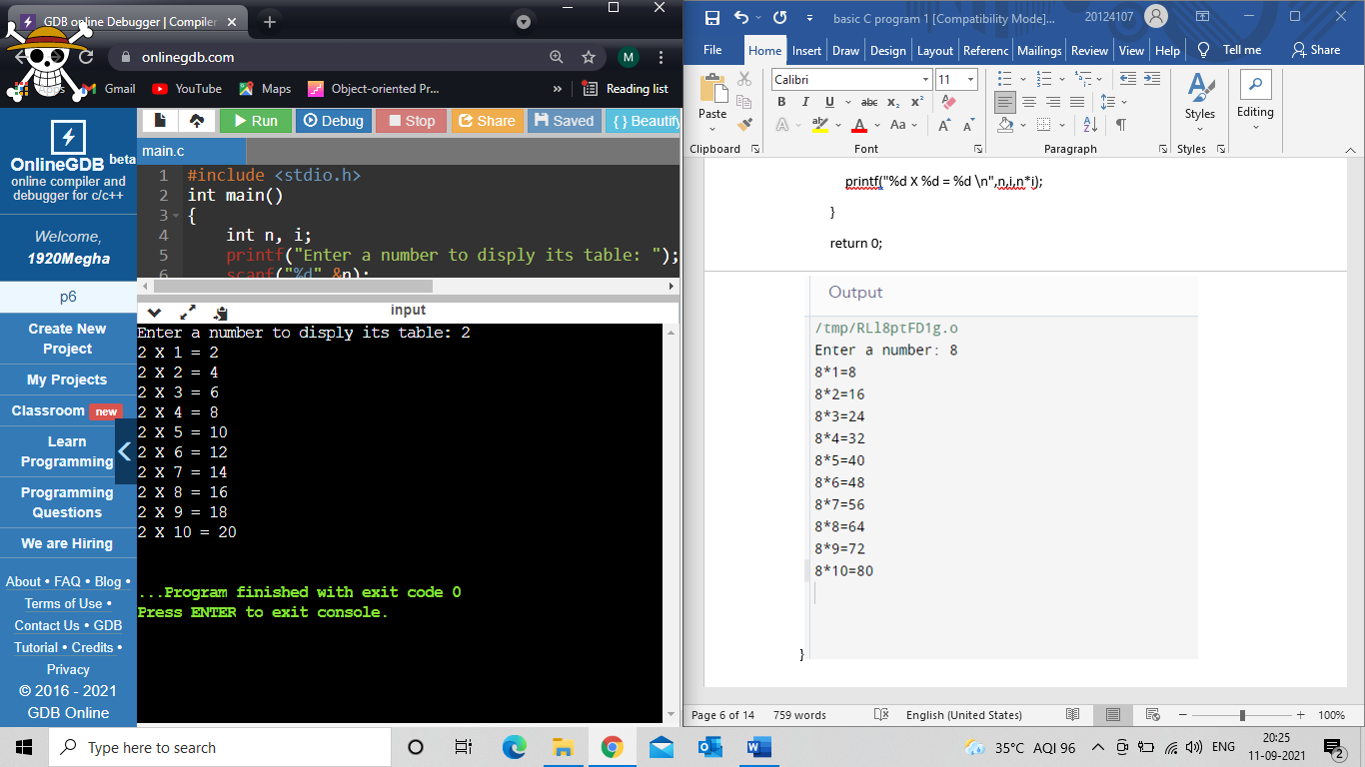

Q.7. C Program to Display Fibonacci Sequence

#include <stdio.h>

int main()

{

int n, i;

int f = 0, ff = 1;

int new = f + ff;

printf("Enter number to display its Fibonacci: ");

scanf("%d",&n);

printf("Fibonacci Series: %d %d ", f, ff);

for (i = 3; i <= n ; ++i)

{

printf("%d ", new);

f = ff;

ff = new;

new = f + ff;

}

return 0;

}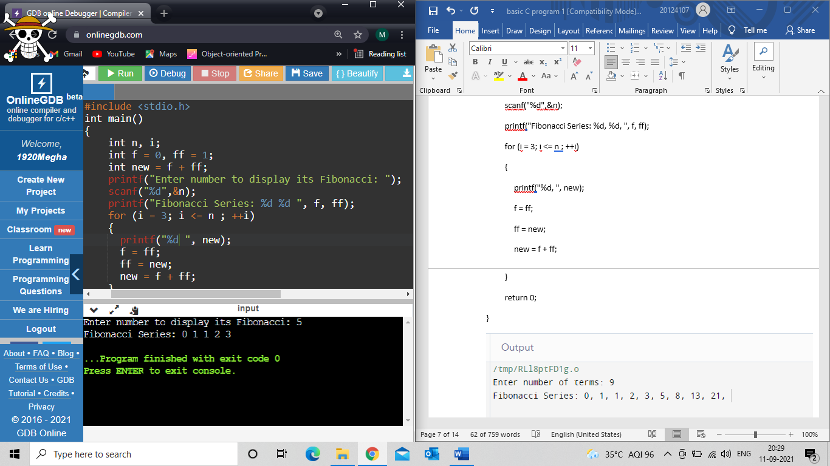

Q.8. C Program to Display Characters from A to Z Using Loop

INPUT:-

#include <stdio.h>

int main()

{

char c;

printf("printing character from A to Z\n");

for (c = 'A'; c <= 'Z'; ++c)

printf("%c ",c);

return 0;

}

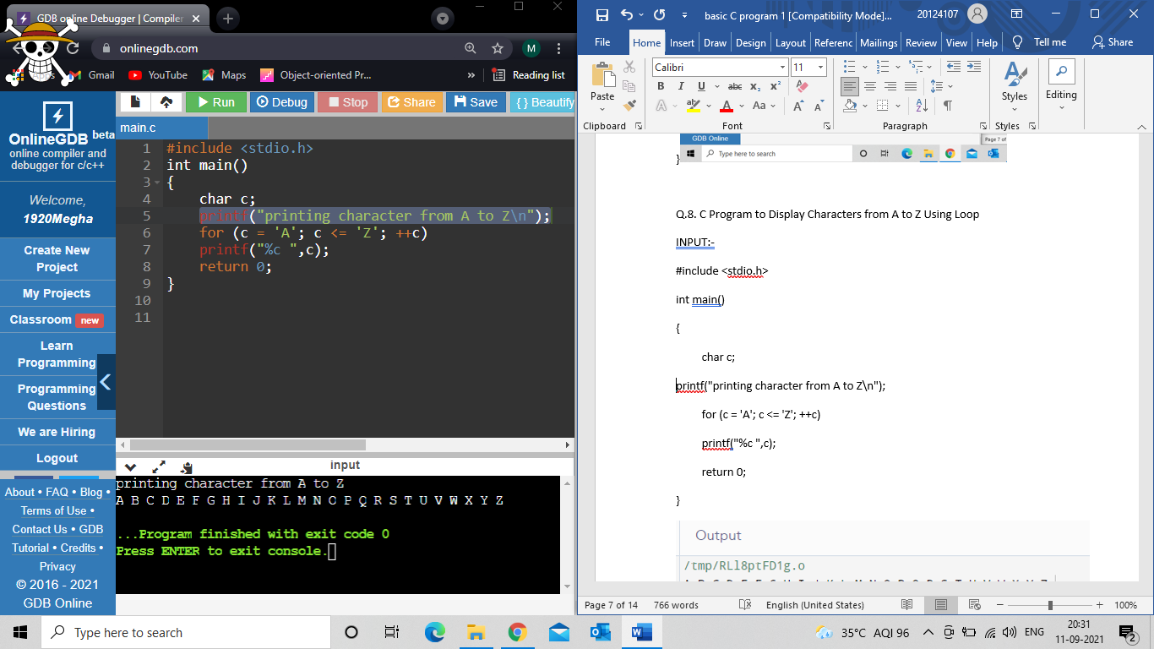

Q.9. C Program to Display Prime Numbers Between Two Intervals

#include <stdio.h>

int main()

{

int n1,n2,i,j,flag;

printf("Enter the starting number and ending number:\n");

scanf("%d %d",&n1,&n2);

printf("Prime number between %d and %d are:", n1, n2);

for(i=n1+1; i<n2; i++)

{

flag = 0;

for(j=2;j<=i/2;++j)

{

if(i%j==0)

{

flag = 1;

break;

}

}

if(flag==0)

printf("%d ",i);

}

return 0;

}

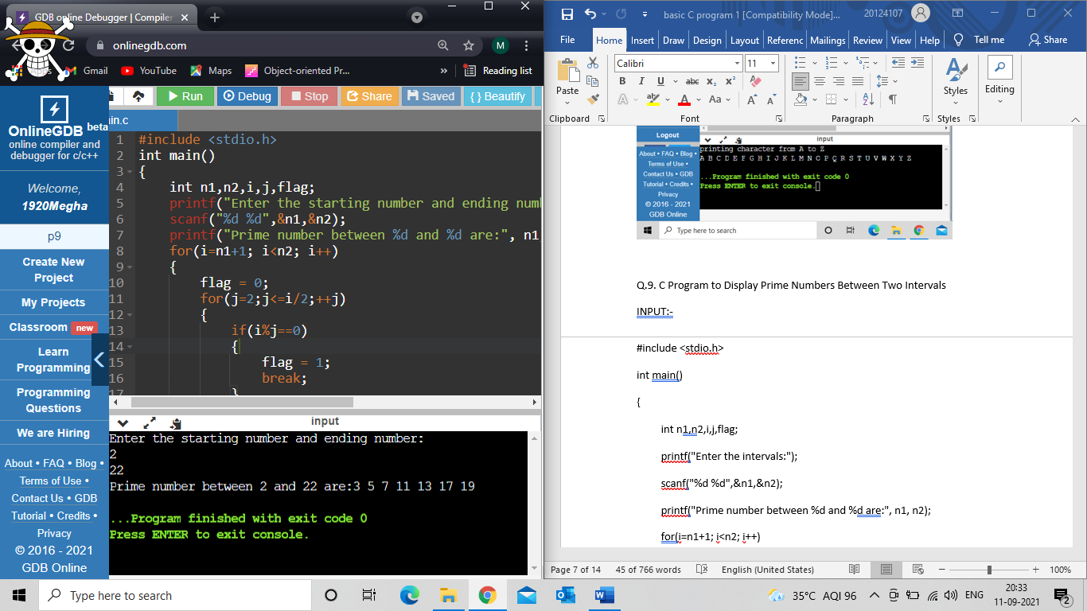

Q.10. C Program to Make a Simple Calculator Using switch...case

#include <stdio.h>

int main()

{

char op;

double first, second;

printf("Enter a operator:\n");

scanf("%C",&op);

printf("Enter two numbers:\n");

scanf("%lf%lf", &first, &second);

switch (op)

{

case '+':

printf("%.1lf + %.1lf = %.1lf", first, second, first + second);

break;

case '-':

printf("%.1lf - %.1lf = %.1lf", first, second, first - second);

break;

case '*':

printf("%.1lf * %.1lf = %.1lf", first, second, first * second);

break;

case '/':

printf("%.1lf / %.1lf = %.1lf", first, second, first / second);

break;

default:

printf("Please try again.");

}

return 0;

}

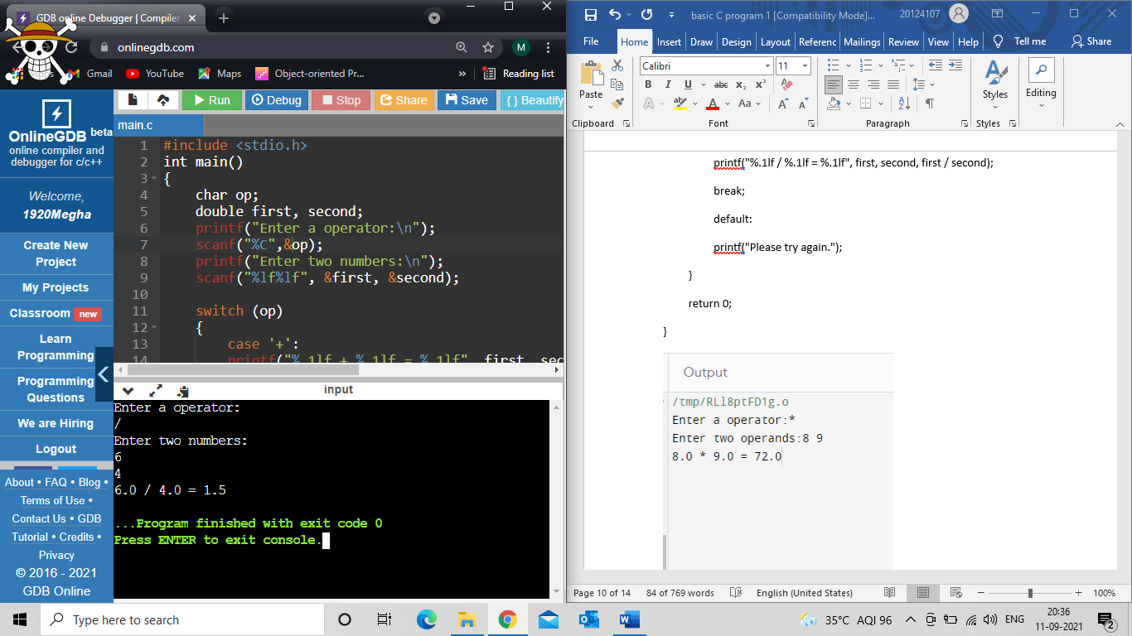

Q.11. C Program to Display Armstrong Number Between Two Intervals

#include <stdio.h>

int main()

{

int n1, n2, i, num, rem, temp;

printf("Enter the starting and ending number to find its armstrong in between\n");

scanf("%d %d", &n1, &n2);

printf("The armstrong numbers between %d and %d are:",n1,n2);

for(i = n1 + 1; i < n2 ; ++i)

{

temp = i;

num = 0;

while(temp != 0)

{

rem = (temp % 10);

num += rem * rem * rem;

temp /= 10;

}

if(i == num)

{

printf("%d ",i);

}

}

return 0;

}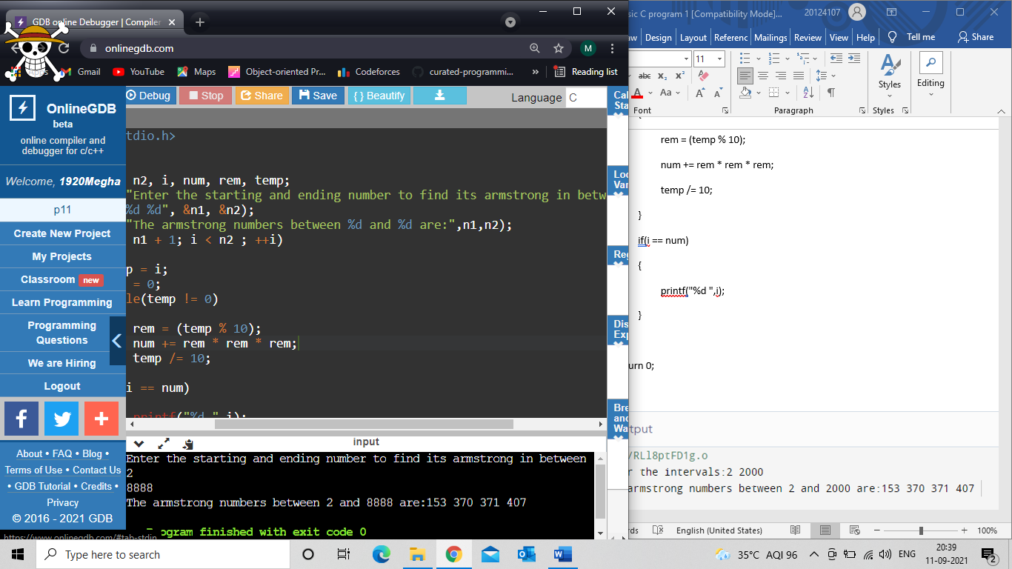

Q.12. C Program to Display Factors of a Number

INPUT:-

#include <stdio.h>

int main()

{

int n, i;

printf("Enter the number to find its fctor:");

scanf("%d", &n);

printf("Factors of %d are:",n);

for(i = 1; i <= n; ++i)

{

if (n % i == 0)

{

printf("%d ",i);

}

}

return 0;

}

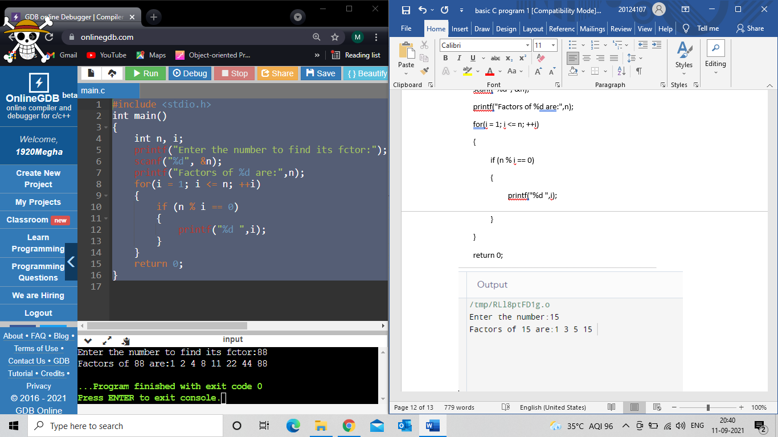

Q.13. Write a C program to reverse given number.

INPUT:-

#include <stdio.h>

int main()

{

int n, reverse = 0, r;

printf("Enter the number to revrse it:\n");

scanf("%d", &n);

while (n != 0)

{

r = n % 10;

reverse = reverse * 10 + r;

n /= 10;

}

printf("The reversed number is: %d",reverse);

return 0;

}

